6. DEPTH FIRST SEARCH (DFS)
Aim
To implement the Depth First Search (DFS) algorithm in Python to traverse all the vertices of a graph using recursion.
Objective
- To understand the working of the DFS algorithm.
- To traverse all the nodes of a graph from a given starting vertex.
- To use recursion for exploring graph vertices in depth-first order.
Algorithm
- Start.
- Create a graph using an adjacency list.
- Create an empty list named visited.
- Read the number of vertices.
- Read each vertex and its adjacent vertices.
- Read the starting vertex.
- Visit the starting vertex and mark it as visited.
- Print the current vertex.
- Recursively visit every unvisited adjacent vertex.
- Repeat until all reachable vertices are visited.
- Stop.

Flow Chart:
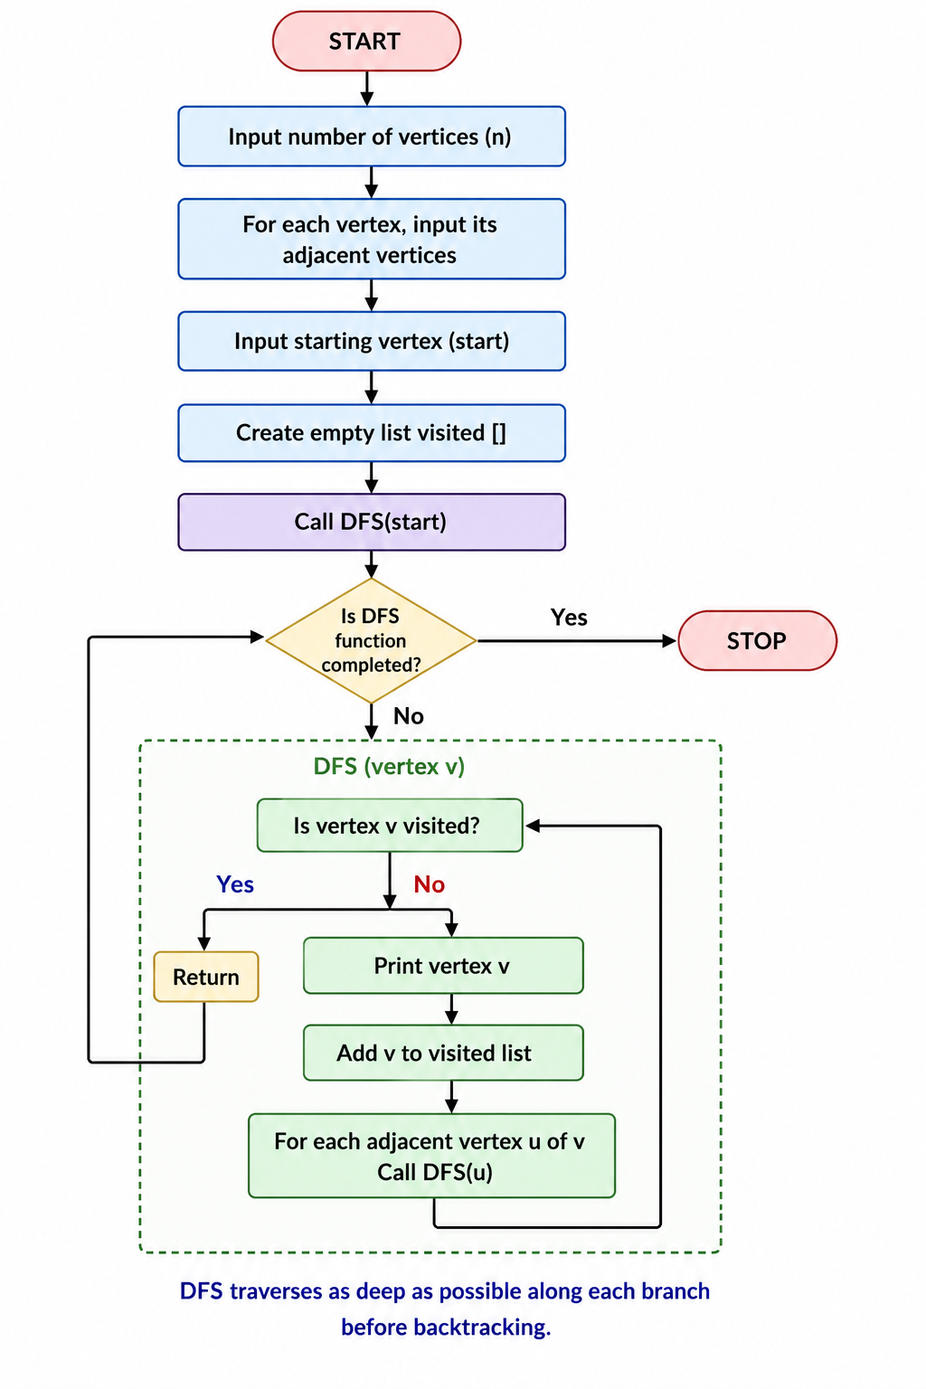
Code:
visited = []
graph = {}

n = int(input("Enter number of vertices: "))

for i in range(n):
vertex = input("Enter vertex: ")
neighbors = input("Enter adjacent vertices (space separated): ").split()
graph[vertex] = neighbors

def dfs(node):
if node not in visited:
print(node, end=" ")
visited.append(node)

for i in graph[node]:
dfs(i)

start = input("\nEnter starting vertex: ")

print("\nDFS Traversal:")
dfs(start)
Output:
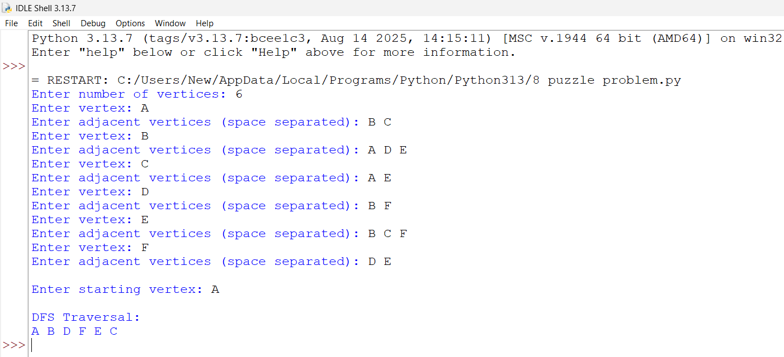
Result:
The Depth First Search (DFS) algorithm was successfully implemented in Python. The graph was traversed by visiting each vertex recursively in depth-first order, and all reachable vertices were visited exactly once.

